**Chapter No. 4**

**Database Design**

**Database Design**

A database is collection of data that is organized in such a way that each piece of data is available to those who need it and such that there is a minimal duplication of data. Database is the shared collection of logically related data, designed to meet the information need multiple users in an organization. The following steps are required to covert data into information acquisition, storage and effectively organizations must organize their data in the form of database.

**4.1 Advantages of Database**

The most common advantages of database may be as follows.

1. Minimal data redundancy
2. Consistency of data
3. Data integrity
4. Sharing of data
5. Ease of application development
6. Uniform security, privacy and integrity controls
7. Reduced program maintenance
8. Improved data security

**4.2  Disadvantages**

1. Database systems are complex, difficult, and time-consuming to design
2. Substantial hardware and software start-up costs
3. Damage to database affects virtually all applications programs
4. Extensive conversion costs in moving form a file-based system to a database system
5. Initial training required for all programmers and users

**4.3 Constraints**

These are the conditions that obey database.

**4.4 Entity**

Any object of concept identified by an enterprise that exists independently and about which it is necessary to store data. It may be anything like a person, a place, an event or concept or an object.

**4.5 Attributes**

An attribute is the Characteristics or property of an entity that is of interest to the organization.

For example, student is an entity; its attributes mostly may be student’s roll no, name, address marks, etc.

**4.6 Keys**

A key is a distinct for each individual entity in an entity set. Key attributes are the attributes whose values are uniquely identified and do not exist again.

### 4.6.1 Super key

A super key is an attribute or a set of attributes that uniquely identifies an entity. For example, student-id is a super key because it can be used to identify each student uniquely.

**4.6.2 Candidate key**

It is also a super key. If A= {studentid, name} then its proper subsets are {studentid} and {name}, then its subset is itself. It means that extra attributes are removed from the super key.

### 4.6.3 Primary key

The primary key is the successful candidate key, the one actually chosen. It may be a single attribute or composite key. The term secondary key is used to mean alternate key but secondary key usually means an attribute or set of attributes whose values not necessarily unique, are used as a mean of accessing records.

### 4.6.4 Foreign key

A foreign key is an attribute or combination of attributes of an entity that is primary key of another entity.

### 4.6.5 Composite key

If the key consists of more than one attribute for unique identification then it will be called as composite key.

**4.7 Normalization**

The major concept is used from the relation data model, used in the developing the conceptual model in this system, is the normalization process. Infect normalization process is the process of grouping the data elements. The definition of these three normal forms is given below. Normalization is a process for converting complex data structures into simple stable data structures.

* **First Normal Form**

A relation is that contain no repeating groups. A relation is in the first normal form if the entire underline domain contains atomic values.

* **Second Normal Form**

A relation is in second normal form if it is in first normal form and every non-key attributes is fully functionally dependent on the primary key. Thus no non-key attribute is functionally dependent on part (but not all) of the primary key.

* **Third Normal Form**

A relation is in third normal form and no transitive dependencies exist.

**4.8 Tables Design:**

**4.8.1 Main table:**

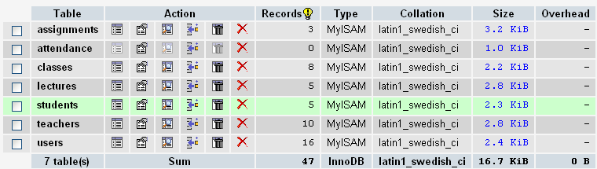

**4.8.2 Assignment Table**

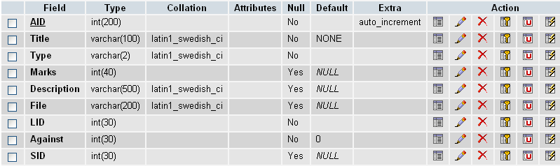

**4.8.3 Attendance Table:-**

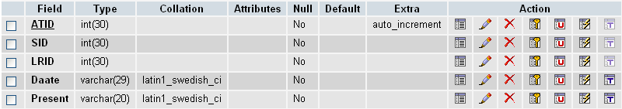

**4.8.4 Class Table:-**

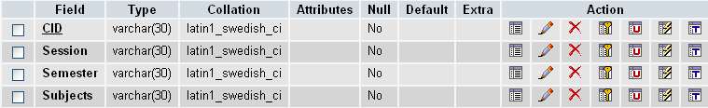

**4.8.5 Lecture Table**

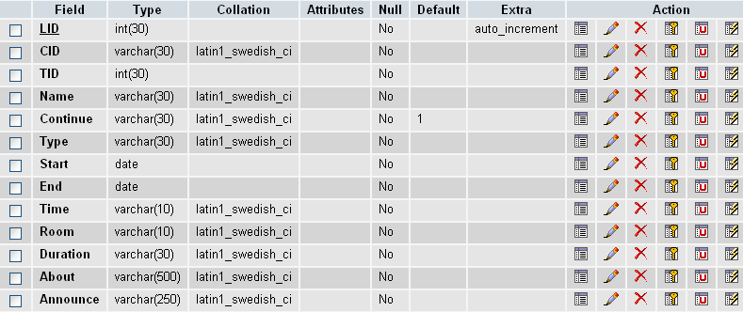

**4.8.6 Student Table**

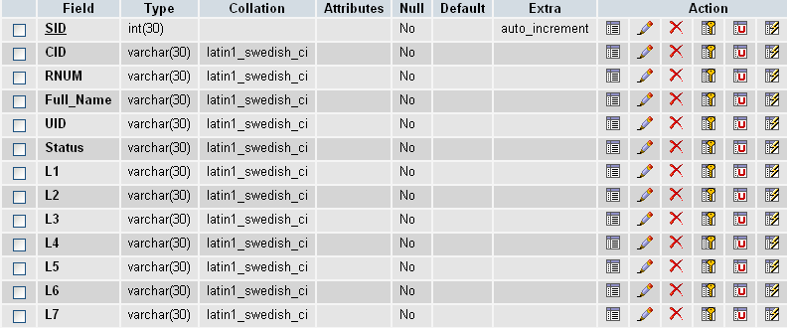

**4.8.7 Teacher Table**

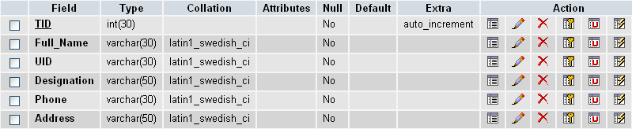

**4.8.8 User Table**

